South Australia
Fences Act 1975
An Act to provide for the erection, replacement, repair and maintenance of fences; and for other purposes.

Contents
1 Short title
3 Saving provisions
4 Interpretation
5 Notice of intention to perform fencing work
6 Cross-notice
7 Agreement upon basis of proposals and counter-proposals
8 Performance of fencing work
9 Whereabouts of adjoining owner unknown
10 No adjoining owner
11 Case where fence divides land from public road and owner of land abutting upon road derives benefit from fence
12 Powers of court
12A Variation of cost of work on appeal
14 Landlord and tenant
15 Contribution as between life tenant and remainderman
16 Damage to or destruction of dividing fence
17 Position of fence does not give rise to title by adverse possession
18 Power of entry
19 Manner in which notice is to be given
20 Application of Act to land of the Crown and councils
21 Extinguishment of prescriptive fencing rights
22 Clearing of scrub in certain areas
23 Departures from requirements of this Act
24 Rules of court
25 This Act is not to derogate from powers conferred by other legislation
Schedule
Legislative history

The Parliament of South Australia enacts as follows:
1—Short title
This Act may be cited as the Fences Act 1975.
3—Saving provisions
(2) Any proceedings commenced pursuant to the repealed Act may be continued and completed subject to and in accordance with the provisions of that Act in all respects as if this Act had not been enacted.
(3) Section 10A and section 11 of the repealed Act shall continue to apply in relation to a dividing fence constructed prior to the commencement of this Act, and any rights that have accrued to any person pursuant to either of those sections, whether before or after the commencement of this Act, may be pursued by him subject to and in accordance with the provisions of the repealed Act.
4—Interpretation
(1) In this Act, unless the contrary intention appears—
adjoining owners means the owners of contiguous land;
cost in relation to fencing work—
(a) includes the cost of any survey that is reasonably required for the purposes of the fencing work; and
(b) includes the cost of any work reasonably required to facilitate the performance of the fencing work; and
(c) where an adjoining owner has done, or proposes to do, any of the work personally, includes a reasonable allowance for his labour;
council means a municipal or district council and includes any body corporate that is, by virtue of any Act, deemed to be, or vested with the powers of, a municipal or district council;
court means the Magistrates Court;
Crown lands means Crown lands within the meaning of the Crown Lands Act;
dividing fence means a fence dividing contiguous land of adjoining owners;
fencing work means the erection of a new dividing fence, or replacement, repair or maintenance work in relation to an existing dividing fence;
owner—
(a) in relation to land alienated from the Crown by grant, means the proprietor at law or in equity of—
(i) an estate of fee simple in the land; or
(ii) a life estate in the land; and
(b) in relation to land of the Crown subject to an agreement for sale, or a right of purchase, means the person entitled to the benefit of that agreement or right of purchase; and
(c) in relation to land held of the Crown under a lease, means the lessee; and
(d) in relation to land held of the Crown under a licence, the term of which exceeds twelve months, means the licensee,
and includes an occupier of land who, with the consent of the owner, carries out, or proposes to carry out, fencing work in relation to the land;
proponent and adjoining owner mean, respectively—
(a) the owner of land who proposes to erect a fence dividing his land from contiguous land, or to perform replacement, repair, or maintenance work in relation to such a fence; and
(b) the owner of that contiguous land;
public road means a road or thoroughfare to which the public has access;
replacement, repair or maintenance work means the replacement, repair or maintenance of the whole or any part of a fence and includes trimming or maintaining any vegetation that serves as a fence, and cleaning, deepening, straightening, enlarging or altering any watercourse, ditch or channel or other geographical configuration that serves as a fence;
the repealed Act means the Fences Act 1924 repealed by this Act.
(2) For the purposes of this Act land is contiguous with other land if—
(a) there is a common boundary between that land and the other land; or
(b) that land is separated from the other land by a right of way of no more than one metre in width.
5—Notice of intention to perform fencing work
(1) Where the owner of any land proposes to erect a fence dividing his land from the land of an adjoining owner, he may serve notice of that intention upon the adjoining owner.
(2) The notice must be in the Form No 1 in the Schedule to this Act and must state—
(a) the length and position of the proposed fence;
(b) the nature of the proposed fence;
(c) an estimate of the cost of the erection of the proposed fence;
(d) the amount that the proponent seeks to recover from the adjoining owner towards the cost of the proposed fence;
(e) where the proposed line of the fence encroaches into the land of the adjoining owner, whether the proponent proposes to pay compensation to the adjoining owner for loss of occupation, and, if so, the amount of that compensation;
(f) the name and address of any contractor or other person by whom the proposed fence is to be erected.
(3) Where the owner of any land proposes to perform any replacement, repair or maintenance work in relation to a fence dividing his land from the land of an adjoining owner, he may serve notice of that intention upon the adjoining owner.
(4) The notice must be in the Form No 2 in the Schedule to this Act and must state—
(a) the nature and location of the proposed work; and
(b) the cost of the proposed work; and
(c) the amount that the proponent seeks to recover from the adjoining owner towards the cost of the proposed work; and
(d) the name and address of any contractor or other person by whom the proposed work is to be performed.
6—Cross-notice
(1) Where an adjoining owner objects to any of the proposals contained in a notice served upon him in pursuance of this Act, he may, within thirty days after the service of the notice, serve a cross-notice upon the proponent.
(2) The cross-notice must be in the Form No 3 in the Schedule to this Act and—
(a) must state to which of the proposals the adjoining owner objects; and
(b) may contain counter-proposals in relation to the proposed erection of a fence or the proposed performance of replacement, repair or maintenance work.
(3) Where the proponent objects to any counter-proposal contained in a cross-notice under this section, he may, within thirty days after the service of the notice, serve notice in writing of his objection upon the adjoining owner.
(4) An objection may be made to a proposal or counter-proposal either because the objector objects generally to the proposals or counter-proposals or because of some specific objection to the proposal or counter-proposal but it shall not be necessary to assign any reason for an objection in a notice under this Act.
7—Agreement upon basis of proposals and counter-proposals
Where a person to whom a proposal or counter-proposal has been made under this Act does not serve notice of his objection to the proposal or counter-proposal in accordance with this Act, he shall be deemed to have agreed to the proposal or counter-proposal.
8—Performance of fencing work
(1) Where notice of the proposed erection of a fence, or the proposed performance of replacement, repair or maintenance work in relation to a fence has been served in accordance with this Act, the proponent may proceed with the fencing work—
(a) after the expiration of thirty days from the date of service of the notice, if he is not served with a cross-notice during that period; or
(b) if he is served with a cross-notice during that period, after agreement has been reached upon the proposals and counter-proposals (if any) or any differences have been adjudicated upon by the court.
(2) Except as otherwise provided in this Act, no contribution shall be recoverable under the provisions of this Act in respect of fencing work performed before the proponent becomes entitled to proceed with the fencing work under subsection (1) of this section.
(3) If the proponent does not proceed with the fencing work within twenty-eight days after the day on which he becomes entitled to do so in accordance with subsection (1) of this section, or such longer period as may be agreed upon by the parties or fixed by the court, the adjoining owner may proceed with the fencing work.
(4) If the fencing work is discontinued by either party for more than twenty-eight days prior to its completion the other party may proceed to complete the work.
(5) If neither the proponent nor the adjoining owner proceeds with the fencing work for a period in excess of the prescribed period, or the work is discontinued for any such period, the agreement shall, as to the part of the work that then remains to be performed, lapse.
(6) The prescribed period referred to in subsection (5) of this section is a period agreed upon by the proponent and the adjoining owner, or determined by order of the court, or in the absence of any such agreement or order, a period of four months.
9—Whereabouts of adjoining owner unknown
(1) Where a person desires to perform fencing work in the nature of erecting, replacing, repairing, or maintaining a dividing fence, and the identity or whereabouts of the adjoining owner has not, after reasonable inquiry by the proponent, been ascertained, he may—
(a) affix a notice of his intention to perform the fencing work in the Form No 1 of the Schedule to this Act on some prominent part of the land of the adjoining owner, and, if no cross-notice is served upon him in accordance with this Act, proceed with the work as if the adjoining owner had agreed to the proposals contained in the notice; or
(b) apply to the court for a determination under subsection (2) of this section.
(2) The court may upon the hearing of an application for a determination under this subsection approve, with or without modification, a proposal for the performance of fencing work submitted to the court by the proponent, and order that an amount, determined by the court, be paid by the adjoining owner towards the cost of the fencing work.
(3) Where the identity and whereabouts of the adjoining owner, or a successor in title to the adjoining owner, are ascertained the proponent or a person claiming under him—
(a) may institute proceedings for the recovery of contribution towards the cost of the fencing work; or
(b) proceed to enforce an order under this section against him.
(4) In proceedings under paragraph (a) of subsection (3) of this section the court may order the payment of such contribution as it considers just in the circumstances.
10—No adjoining owner
(1) Where a person proposes to perform fencing work in the nature of erecting, replacing, repairing or maintaining a dividing fence, and there is no adjoining owner of the contiguous land from which his land is or is to be divided, he may apply to the court for a determination under this section.
(2) The court may, upon the hearing of the application approve, with or without modification, a proposal for the performance of fencing work submitted to the court by the proponent, and may order that when a person becomes the owner of the contiguous land, he shall pay to the proponent an amount, determined by the court, towards the cost of the fencing work.
11—Case where fence divides land from public road and owner of land abutting upon road derives benefit from fence
(1) Where a person has erected a fence dividing his land from a public road, and any other person who is the owner of land abutting upon the road derives use of, or benefit from the fence, by reason of the proximity of the fence to his own land the person by whom the fence has been erected may institute proceedings in the court for the recovery from that other person of a contribution towards the cost of erecting the fence or any further fencing work in relation to the fence.
(2) The court may order the person against whom the proceedings are taken to make such contribution as it considers just in view of the benefit that he derives in consequence of the erection of the fence or the performance of the further fencing work.
12—Powers of court
(1) Where any difference or dispute arises in relation to fencing work, or any liability arising under this Act, any person affected by the difference or dispute may by application to the court seek a determination of the matter.
(2) Upon the hearing of an application under subsection (1) of this section the court may determine the matter in such manner as it considers just and may—
(a) make any finding, determination or order in relation to the erection of a fence, the nature of the fence to be erected, the line of fence to be adopted and the amount of compensation (if any) to be paid for loss of occupation of land as a result of the erection of a fence otherwise than upon the boundary of contiguous land; and
(b) make any finding, determination or order in relation to the performance of replacement, repair or maintenance work in relation to a dividing fence; and
(c) determine the person or persons by whom any fencing work is to be performed, and where it is to be performed by different persons, the part of the work to be performed by each; and
(d) re-open and correct or vary any agreement arrived at under this Act (including an agreement that is, by virtue of section 7 of this Act, deemed to have been made) upon such terms as the court considers just; and
(e) re-consider and vary upon such terms as the court considers just an order under section 9 or section 10 of this Act; and
(f) determine the time at which fencing work is to be performed and the manner of its performance; and
(g) make any order that may be necessary or expedient in relation to entry upon or access to land for the purposes of performing fencing work; and
(h) order the removal of a fence or any portion of a fence not erected upon the proper boundary; and
(i) determine the cost of fencing work and the persons by whom and the proportions in which the cost is to be borne; and
(j) make any order or give any direction that may be necessary or expedient to overcome difficulties ascertained during the progress of fencing work; and
(k) determine, and order payment of, compensation for any damage for which compensation is payable under this Act, or any other Act or law; and
(l) make such order for costs as the court considers just.
(3) The court may, on the application of any interested person, extend any limitation of time prescribed by this Act (whether or not the time so limited has expired).
(4) Where the owner of land claims to be entitled to the payment of an amount from an adjoining owner in respect of the performance of fencing work either in pursuance of the provisions of this Act, or any agreement under this Act, he may apply to the court for an order for payment of that amount.
(5) The court may upon an application under subsection (4) of this section make an order for any person to pay an amount for which he is so liable.
(6) Subject to subsection (7) of this section, any dispute as to the relative proportion in which the cost of fencing work is to be borne as between adjoining owners shall be determined according to the benefit that each of the adjoining owners derives from the performance of the fencing work, and, in the absence of proof to the contrary it shall be presumed that the adjoining owners derive equal benefit from the performance of the fencing work.
(7) If fencing work consists in the erection of an adequate fence or a fence of better quality than an adequate fence, or the conversion of an existing fence into an adequate fence or a fence of better quality than an adequate fence, then, in the absence of agreement between the adjoining owners, the contribution for which an adjoining owner is liable shall be one-half of the minimum cost of erecting an adequate fence, or converting the existing fence into an adequate fence.
(8) For the purposes of this section—
(aa) in the case of a fence dividing land, of not less than 0.8 hectare in area, used for primary production purposes from land used for residential or other purposes—an adequate fence is a fence that is adequate for the primary production purposes or a fence that is adequate for the residential or other purposes, whichever would cost less; and
(a) in any other case—an adequate fence is a fence that conforms with general standards of good fencing existing in the locality in which the fencing work has been or is to be performed and is adequate for the purposes of the owner against whom contribution is sought; and
(b) a fence may be an adequate fence notwithstanding that it is discontinuous where any vegetation, watercourse, ditch or other geographical configuration serves as a fence or portion thereof.
(9) Any person who is, in accordance with this Act, liable to either of the adjoining owners of land in respect of fencing work shall be entitled to appear in any proceedings relating to that fencing work under this section.
(10) In this section—
primary production purposes means agriculture, pasturage, horticulture, viticulture, apiculture, poultry farming, dairy farming, forestry or any other activity consisting of the cultivation of soils, the gathering in of crops, the rearing of livestock or the propagation and harvesting of fish or other aquatic organisms.
12A—Variation of cost of work on appeal
On an appeal against a determination or order of the court, the court hearing the appeal may, in addition to any other order it may make, vary any determination as to the cost of fencing work to take account of any variation in the cost subsequent to the determination.
14—Landlord and tenant
(1) Subject to any agreement between a landlord and tenant and the provisions of this section, the landlord may recover, as a debt due to him, contribution towards the satisfaction of any liability incurred by the landlord during the tenancy in respect of fencing work performed in relation to fences dividing the land occupied by the tenant from the land of adjoining owners.
(2) The contribution recoverable under subsection (1) of this section shall be determined in accordance with the following principles:
(a) where at the time of the performance of the fencing work a period of less than three years remains of the term of the tenancy, no contribution is payable by the tenant; and
(b) where at the time of the performance of the fencing work a period of at least three years but less than six years remains of the term of the tenancy, a contribution of one-quarter of the liability incurred by the landlord is payable by the tenant; and
(c) where at the time of the performance of the fencing work a period of at least six years but less than twelve years remains of the term of the tenancy, a contribution of one-half of the liability incurred by the landlord is payable by the tenant; and
(d) where at the time of the performance of the fencing work a period of at least twelve years remains of the term of the tenancy, the landlord may recover a sum sufficient to satisfy his total liability from the tenant.
(3) Subject to any relevant agreement, where a tenant exercises a right or option to purchase land occupied by him for a sum fixed in an agreement, or fixed in accordance with principles contained in an agreement, with the landlord, the former landlord may recover as a debt from the former tenant, in augmentation of the purchase price, any sum paid by the landlord during the tenancy, in respect of fencing work relating to the land subject to the tenancy.
(4) It shall be a defence to an action for the recovery of any moneys under this section that—
(a) the fencing work was not required as a result of any act or default on the part of the tenant; and
(b) the tenant was not afforded adequate opportunity to make representations in relation to the proposals and counter-proposals (if any) before they became binding on the landlord or was afforded such an opportunity and objected to the proposals or counter-proposals by notice in writing served upon the landlord a reasonable time before the proposals or counter-proposals became binding upon him; and
(c) the tenant was not bound by the order of a court to make contribution towards the cost of the fencing work by order of a court made pursuant to the provisions of this Act before the commencement of the fencing work.
15—Contribution as between life tenant and remainderman
(1) Where a life tenant incurs any liability for fencing work, he shall be entitled to recover from the remainderman or the reversioner a contribution towards that liability.
(2) The contribution to which a life tenant is entitled under this section shall be the proportion of the liability incurred by the life tenant that the value of the interest of the remainderman or reversioner bears to the value of an estate of fee simple in the land.
16—Damage to or destruction of dividing fence
(1) Subject to this section, where a dividing fence is damaged or destroyed, and there is an urgent need to repair or restore the fence, either of the adjoining owners may, without notice to the adjoining owner, carry out the requisite fencing work and recover from the other adjoining owner—
(a) one-half of the cost of the fencing work; or
(b) the amount that the other adjoining owner would be liable to contribute if the dividing fence were to be replaced,
whichever is the lesser.
(2) Where a dividing fence is damaged or destroyed as a result of a wrongful act or default on the part of any person, an adjoining owner who has properly incurred any cost or expense in repairing or restoring the fence (whether in pursuance of this Act or otherwise) may recover from that person, as a debt, the cost or expense so incurred.
(3) An adjoining owner shall not be entitled to recover contribution for any fencing work under this Act in so far as that fencing work consists in the repair of damage resulting from his own wrongful act or default.
17—Position of fence does not give rise to title by adverse possession
Notwithstanding the provisions of the Real Property Act, where a dividing fence is erected otherwise than upon the boundary to contiguous land either in pursuance of an agreement under this Act, or of an order of the court, neither of the adjoining owners shall, by reason of his occupation of the land enclosed by the fence, be deemed to be in adverse possession of any land of the other so as to acquire title to that land in derogation of the title or interest of the other.
18—Power of entry
(1) Subject to subsection (2) of this section and to any agreement or order, any person may, for the purpose of carrying out authorised fencing work, enter at any reasonable time upon land with any vehicle or equipment reasonably required for the purposes of the fencing work and do anything that may be reasonably required for the purposes of the fencing work.
(2) Except in the case of an emergency, the powers conferred by this section shall not be exercised unless at least two days before the land is entered in pursuance of this section notice in writing of the intended entry has been served upon the owner of the land.
(3) The powers conferred by this section shall be exercised as far as reasonably practicable so as not to cause injury to the land or property of any other person.
(4) In this section—
authorised fencing work means—
(a) fencing work in respect of which agreement has been reached in pursuance of this Act; or
(b) fencing work authorised in accordance with the order of a court; or
(c) fencing work otherwise authorised by this Act.
19—Manner in which notice is to be given
(1) Any notice under this Act must be signed by the person giving the notice or his solicitor, attorney or agent.
(2) Service of a notice under this Act must be effected personally or by registered post.
20—Application of Act to land of the Crown and councils
(1) Subject to subsection (2) of this section, this Act applies in respect of land of the Crown, an instrumentality or agency of the Crown, or a council.
(2) This Act does not apply in respect of any such land where—
(a) the land comprises, or is comprised in, a single parcel of land of more than one hectare in area; or
(b) the land comprises, or is comprised in a public road or a road reserve; or
(c) the land is exempted by regulation from the provisions of this Act.
(3) The Governor may, by regulation, exempt specified land, or land of a specified class, from the provisions of this Act.
21—Extinguishment of prescriptive fencing rights
Any obligation to fence land, or to maintain a fence in a state of repair, that may exist by prescription, is hereby extinguished.
22—Clearing of scrub in certain areas
(1) Where a person proposes to perform fencing work on land, he may clear all scrub up to a width of two metres on each side of the fence, or the line of the proposed fence, and the cost of clearing the scrub shall be deemed to be part of the cost of performing the fencing work.
(2) The Governor may, by regulation, declare that this section shall not apply in respect of fencing work upon land, or land of a kind, specified in the regulation and the application of this section shall be modified accordingly.
23—Departures from requirements of this Act
(1) A notice or cross-notice that complies in substance with the requirements of this Act shall, notwithstanding that it is not in the form required by this Act, be deemed to comply with this Act.
(2) Where fencing work is carried out substantially in conformity with an agreement or order under this Act, the court before which any proceedings relating to the fencing work are brought may determine that subject to any adjustment or rights and liabilities ordered by the court, the rights and liabilities of the adjoining owners shall be determined as if the fencing work had been carried out in conformity with that agreement or order.
(3) Where a determination is made under subsection (2) of this section the rights and liabilities of the adjoining owners shall be determined in accordance with that determination.
(4) The court may not, when determining a matter in a minor civil action under this Act, exercise any discretionary power to disregard a requirement or provision of this Act or to provide a special form of relief that the court would (but for this subsection) be able to exercise only by virtue of the provisions of the Magistrates Court Act 1991 relating to minor civil actions.
24—Rules of court
Rules of court regulating the practice and procedure of the court in proceedings under this Act may be made subject to and in accordance with the Local and District Criminal Courts Act 1926.
25—This Act is not to derogate from powers conferred by other legislation
The provisions of this Act shall not be construed as derogating from powers conferred upon any authority, body or person by any other Act.

Schedule
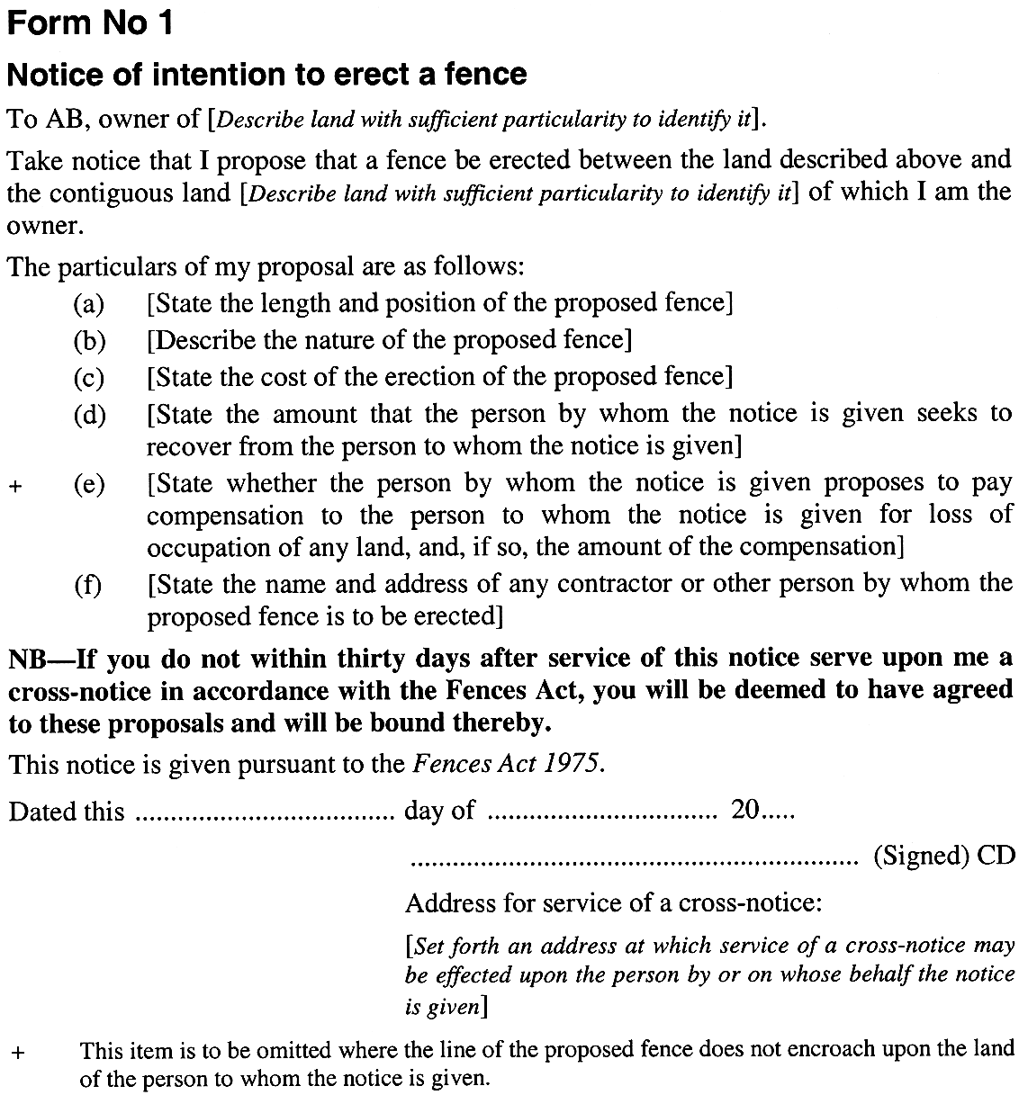
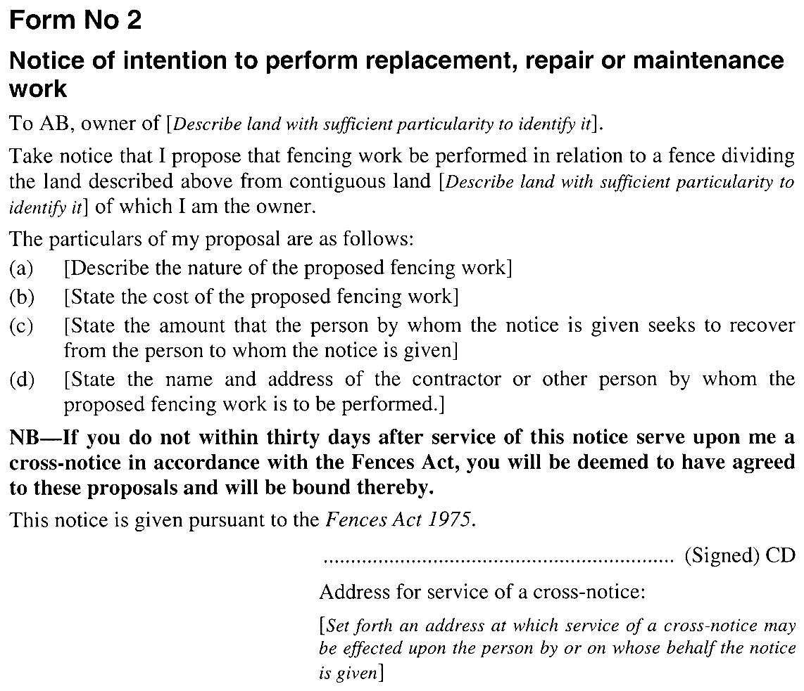
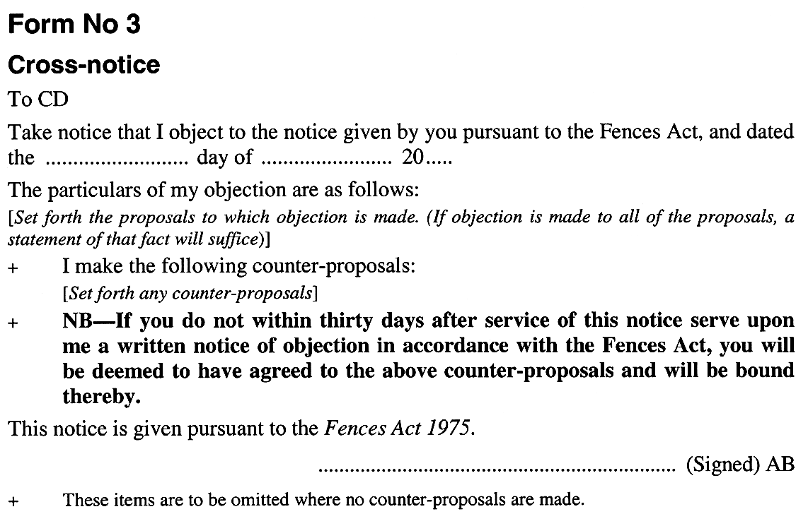

Legislative history
Notes
• Please note—References in the legislation to other legislation or instruments or to titles of bodies or offices are not automatically updated as part of the program for the revision and publication of legislation and therefore may be obsolete.
• Earlier versions of this Act (historical versions) are listed at the end of the legislative history.
• For further information relating to the Act and subordinate legislation made under the Act see the Index of South Australian Statutes or www.legislation.sa.gov.au.
Legislation repealed by principal Act
The Fences Act 1975 repealed the following:
Fences Act 1924
Fences Act Amendment Act 1926
Principal Act and amendments
New entries appear in bold.
Year | No | Title | Assent | Commencement
1975 | 44 | Fences Act 1975 | 10.4.1975 | 16.10.1975 (Gazette 16.10.1975 p2011)
1977 | 23 | Fences Act Amendment Act 1977 | 12.5.1977 | 16.10.1975: s 2
1983 | 63 | Fences Act Amendment Act 1983 | 22.9.1983 | 22.9.1983
1990 | 57 | Fences Act Amendment Act 1990 | 29.11.1990 | 6.6.1991 (Gazette 6.6.1991 p1776)
1991 | 69 | Statutes Repeal and Amendment (Courts) Act 1991 | 12.12.1991 | 6.7.1992 (Gazette 2.7.1992 p209)
1995 | 27 | Statutes Amendment (Attorney-General's Portfolio) Act 1995 | 27.4.1995 | s 14—10.7.1995 (Gazette 29.6.1995 p2973)
1997 | 59 | Statutes Amendment (Attorney-General's Portfolio) Act 1997 | 31.7.1997 | Pt 5 (ss 7 & 8)—14.9.1997 (Gazette 11.9.1997 p704)
Provisions amended since 3 February 1976
• Legislative history prior to 3 February 1976 appears in marginal notes and footnotes included in the consolidation of this Act contained in Volume 4 of The Public General Acts of South Australia 1837-1975 at page 80.
New entries appear in bold.
Entries that relate to provisions that have been deleted appear in italics.
Provision | How varied | Commencement
Long title | amended under Legislation Revision and Publication Act 2002
s 2 | omitted under Legislation Revision and Publication Act 2002
s 3
s 3(1) | omitted under Legislation Revision and Publication Act 2002
s 3(3) | inserted by 23/1977 s 3 | 16.10.1975
s 4
s 4(1)
court | substituted by 69/1991 s 12(a) | 6.7.1992
s 12
s 12(8) | amended by 59/1997 s 7(a), (b) | 14.9.1997
s 12(10) | inserted by 59/1997 s 7(c) | 14.9.1997
s 12A | inserted by 57/1990 s 3 | 6.6.1991
s 13 | amended by 63/1983 s 2 | 22.9.1983
 | substituted by 57/1990 s 4 | 6.6.1991
 | deleted by 69/1991 s 12(b) | 6.7.1992
s 16
s 16(1) | substituted by 59/1997 s 8 | 14.9.1997
s 20
s 20(2) | amended by 23/1977 s 4(a)—(c) | 16.10.1975
s 20(3) | inserted by 23/1977 s 4(d) | 16.10.1975
s 23
s 23(4) | inserted by 27/1995 s 14 | 10.7.1995
Historical versions
Reprint No 1—1.7.1991
Reprint No 2—6.7.1992
Reprint No 3—10.7.1995

